
NETWORKING CONCEPTS

- IP Address: An IP Address is a unique number assigned to a device connected to a network. It helps devices communicate over the internet.
- DNS (Domain Name System): DNS converts website names such as google.com into IP addresses that computers can understand.
- Domain Name: A domain name is the human-readable address of a website, such as google.com or youtube.com.
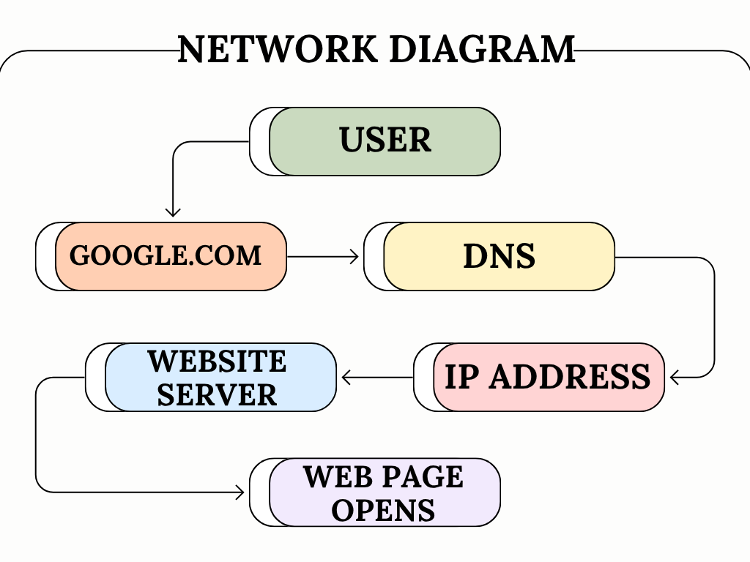
- Hosting: Hosting is a service that stores website files and makes them available on the internet.

